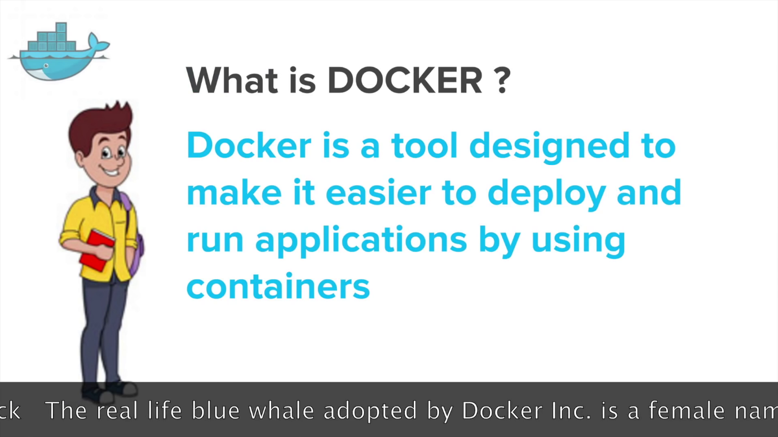

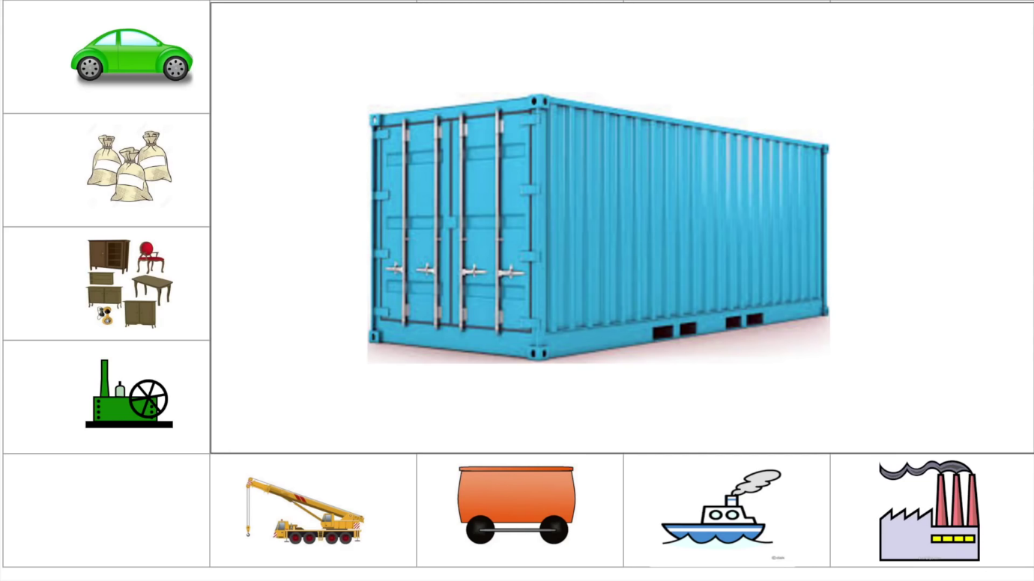

VM vs Container

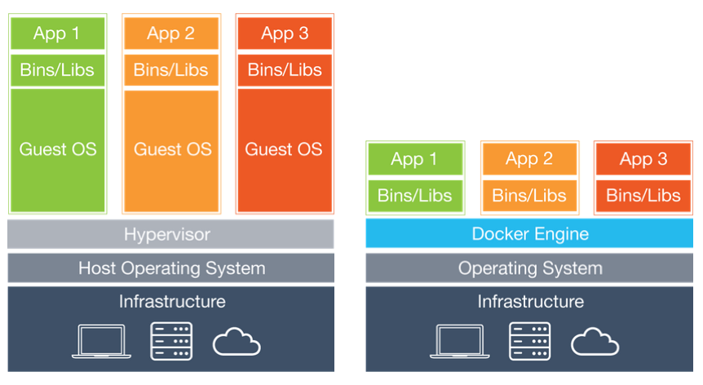

# [**etc/ bin/ and lib/**](https://stackoverflow.com/questions/16643142/what-do-these-directory-is-used-for-in-linux-etc-bin-and-lib)

* etc -> To keep configuration files
* lib -> To keep libraries that can be used by installed software or other softwares in your system.
* bin -> Binary files

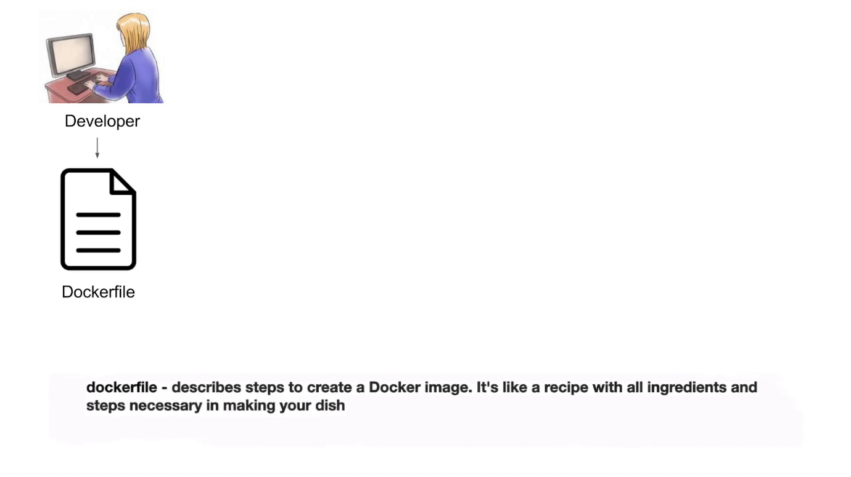

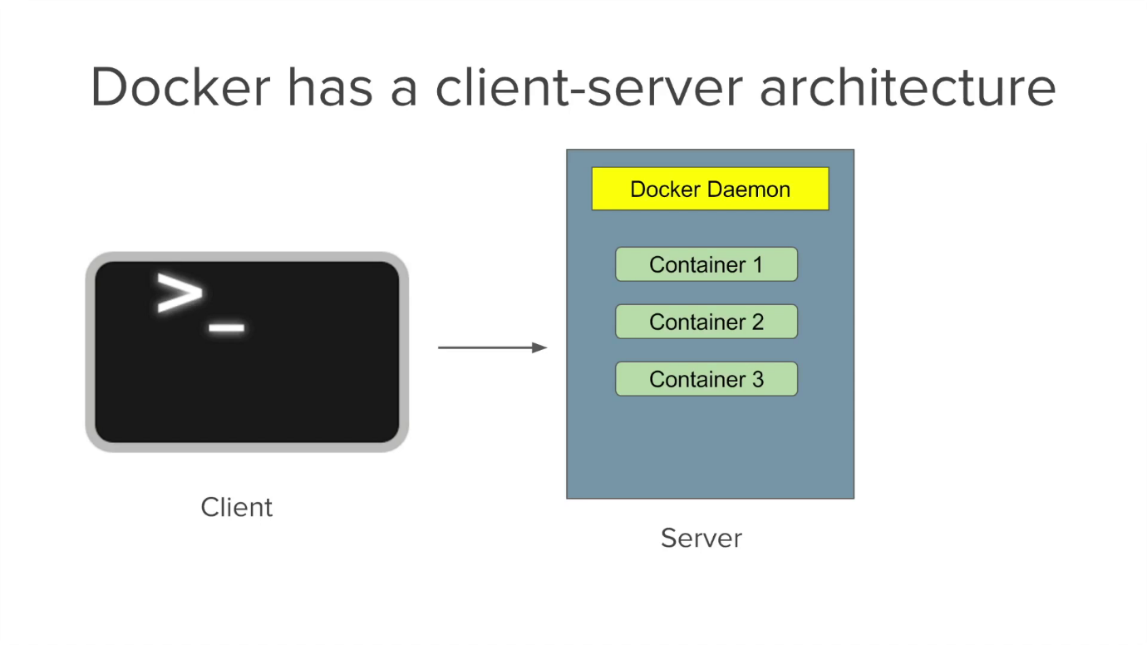

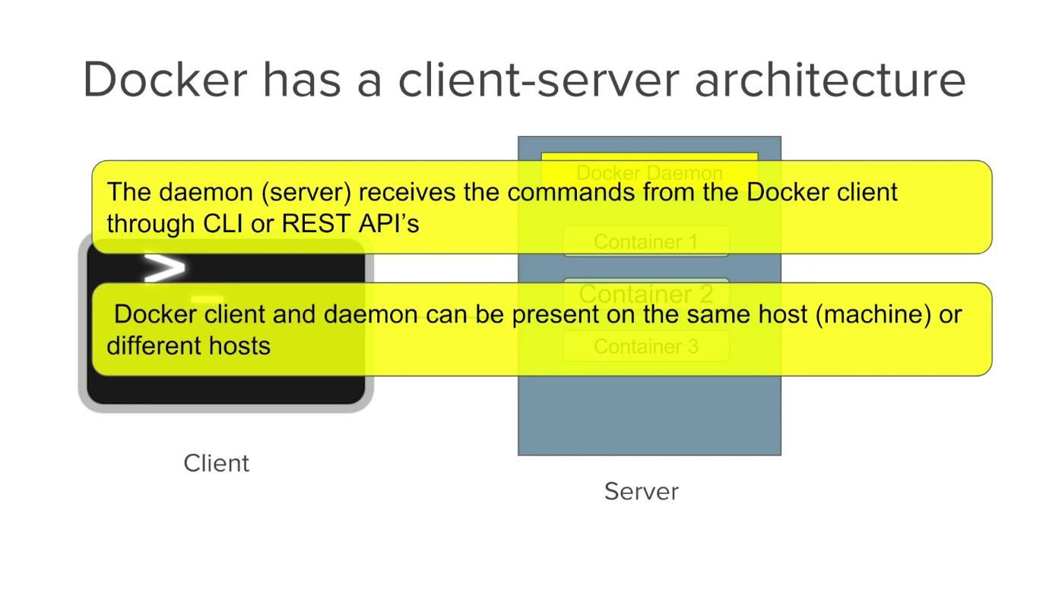

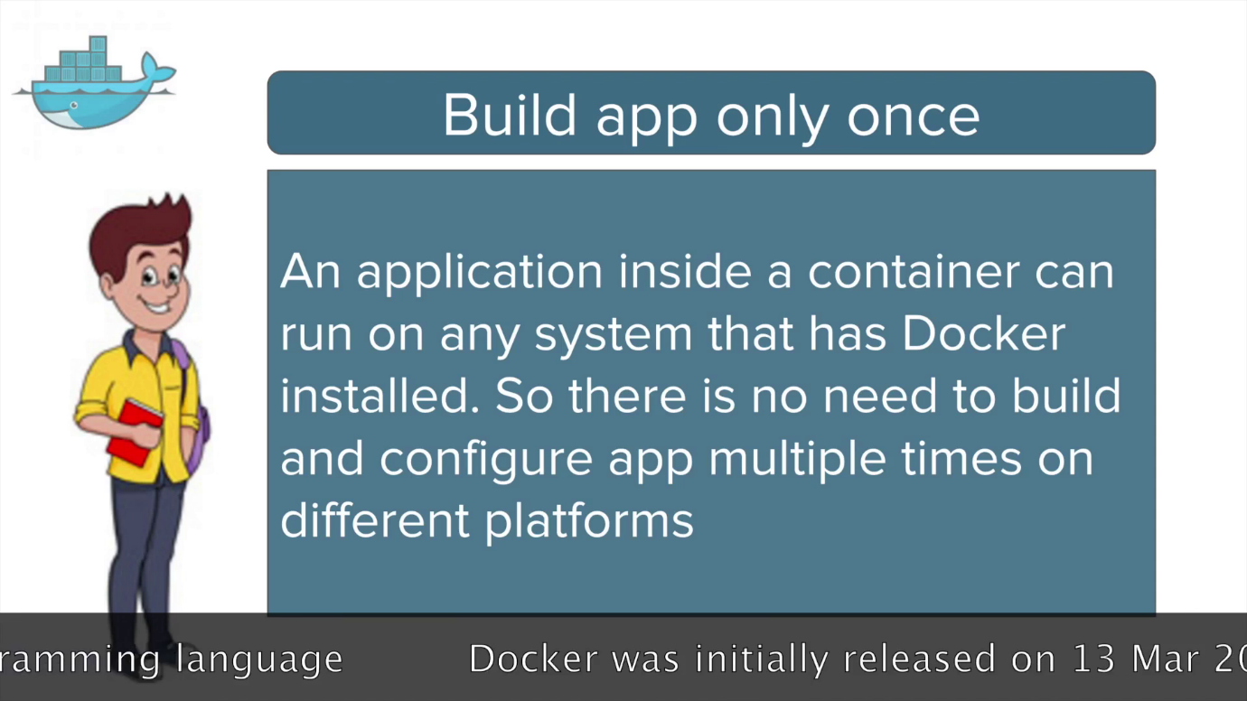

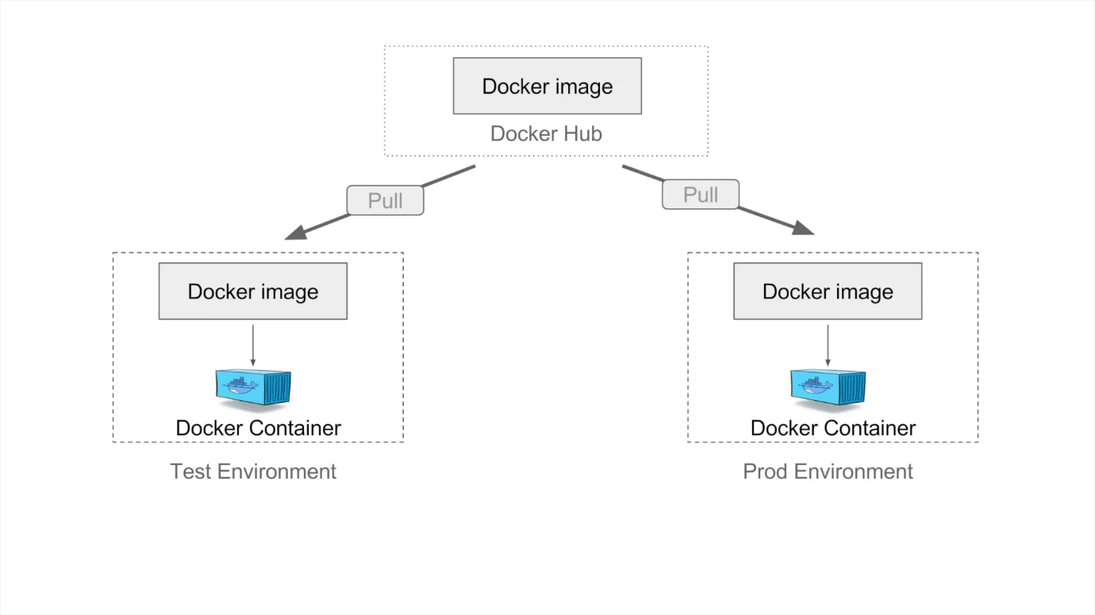

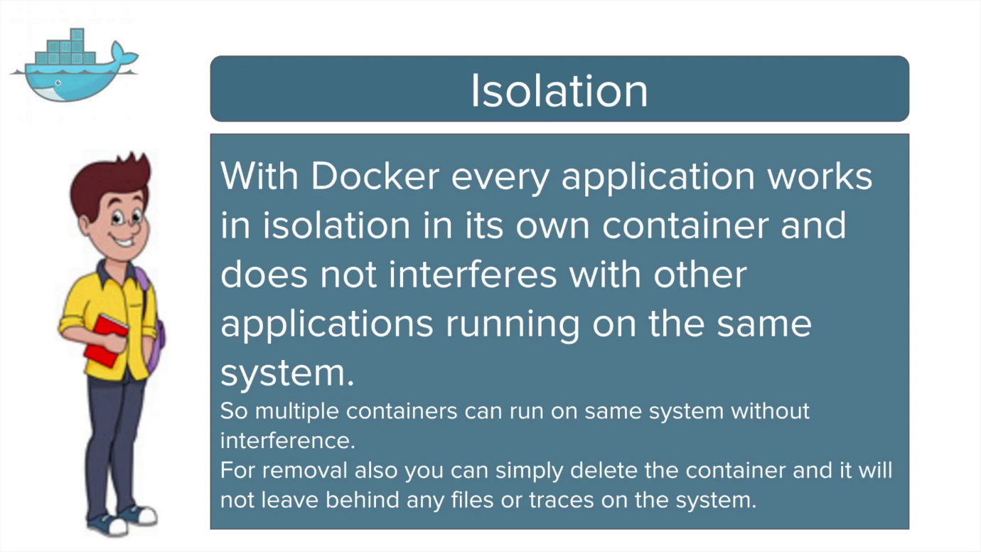

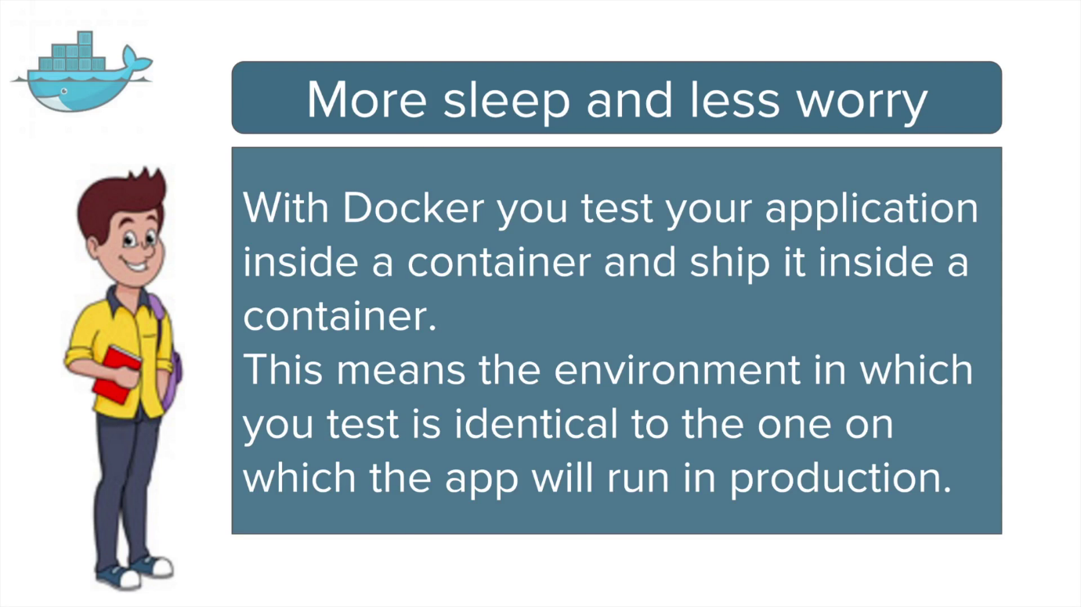

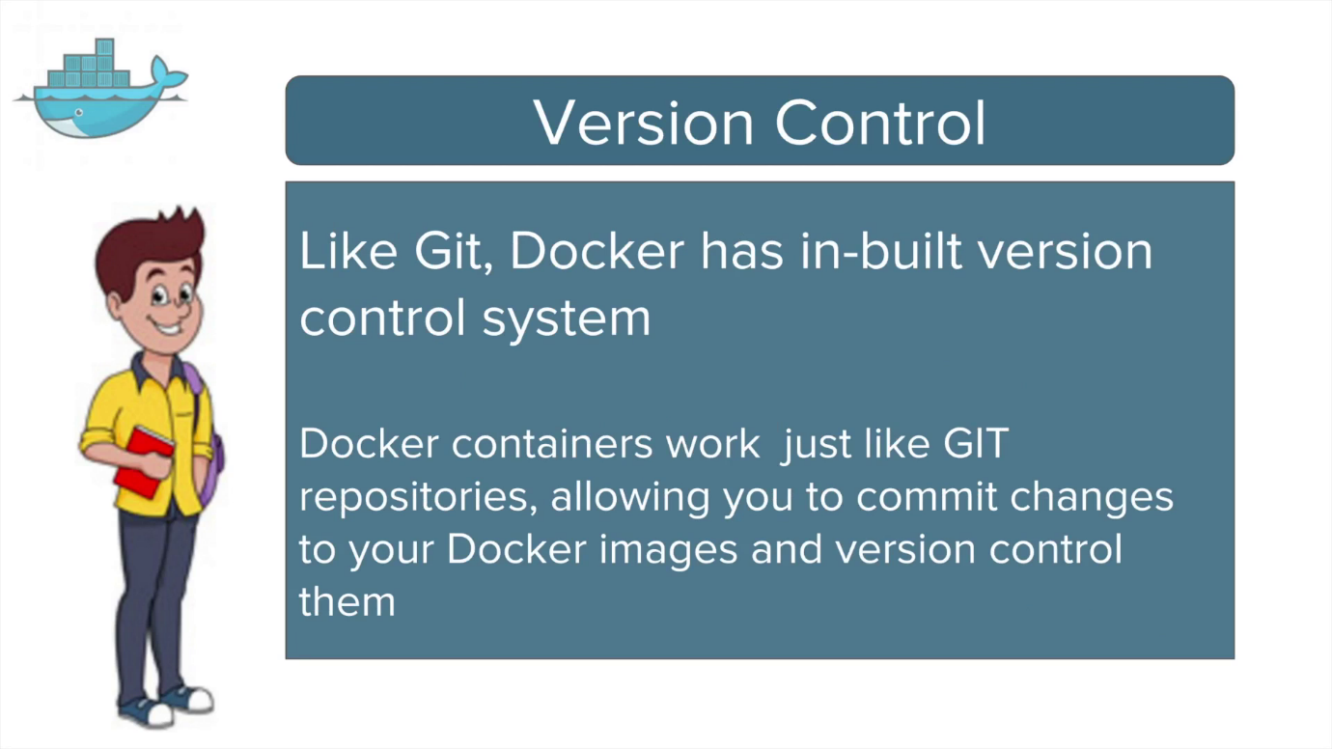

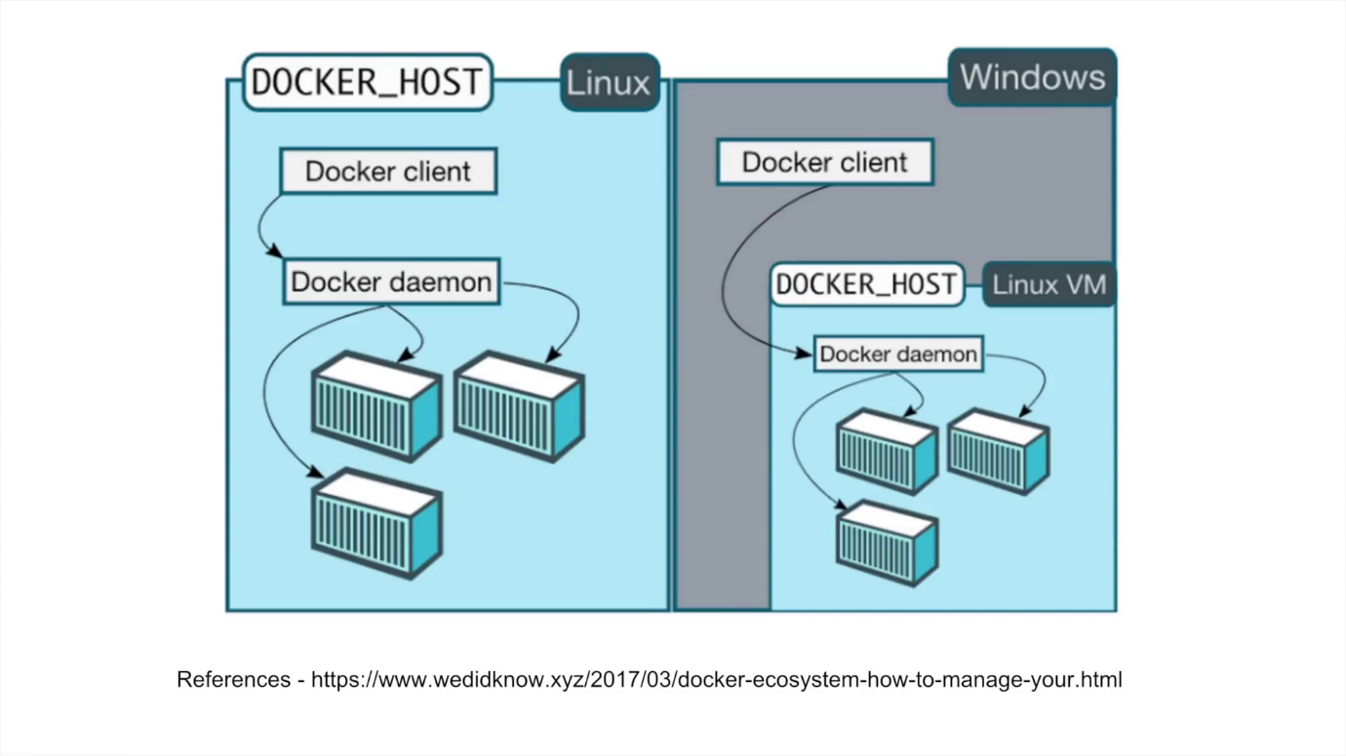

Installation of Docker on linux/rhel

<https://www.cyberciti.biz/faq/install-use-setup-docker-on-rhel7-centos7-linux/>

<https://www.cyberciti.biz/faq/install-use-setup-docker-on-rhel7-centos7-linux/>

**Docker commands:**

**Docker build :** Build an image from a Dockerfile

**Ex:** docker build -t aaa-docker .

docker build -t aaa-docker -f /lakshman/Dockerfile

**Docker tag:**

docker tag SOURCE_IMAGE[:TAG] TARGET_IMAGE[:TAG]

Ex: docker tag aaa-dockerimg aaa-repo-can:data

**Docker pull to download images from registry:**

Ex: docker pull aaa-core-docker-candidates.repo.lab.pl.alcatel-lucent.com/aaa-dockerimg:19A.20190516061205

**Docker images –** to list of all the docker images

**docker run -itd image-name/ID / docker run image-name : to bring-up container using docker image**

**docker ps – > to list only running containers**

**docker container ls -a / docker container ls -a –> to list of all active and inactive containers**

**docker exec -it container-id bash -> to login into the docker container**

Docker stop continer-id -> to stop the container.

Docker container start container-id -> to start stopped containers.

Docker rmi docker-image/img-id : to delete the docker images

**To stop and delete all containers:**

docker stop $(docker ps -a -q)

docker rm $(docker ps -a -q)

**if want to delete docker images – first you have to stop running containers and remove container then delete.**

Docker stop container-id -> to stop container

Docker rm container-id -> to delete container

**copying files from host to container:**

$ docker ps

CONTAINER ID IMAGE COMMAND CREATED STATUS PORTS NAMES

72ca2488b353 my_image X hours ago Up X hours my_container

docker cp foo.txt 72ca2488b353:/foo.txt

docker cp 72ca2488b353:/foo.txt foo.txt

**To run docker container with port:**

**docker run -itd -p 8445:8445 d11244e66cf9**

**Helm:**

[Helm](https://www.helm.sh/) is a package manager for Kubernetes that allows developers and operators to more easily package, configure, and deploy applications and services onto Kubernetes cluster.

Helm helps you manage Kubernetes applications — Helm Charts help you define, install, and upgrade even the most complex Kubernetes application.

Charts are easy to create, version, share, and publish — so start using Helm and stop the copy-and-paste.

**Kubernetes**

